CS 255 System Design Document Template

This template lays out all the different sections that you need to complete for Project Two. Each section has guidance to prompt your thinking. You will need to continually reference the interview transcript as you work to make sure that you are addressing your client’s needs. There is no required length for the final document. Instead the goal is to complete each section based on what your client’s needs are. Remove this note when you are finished, and replace all bracketed text with the relevant information.

UML Diagrams

UML Use Case Diagram
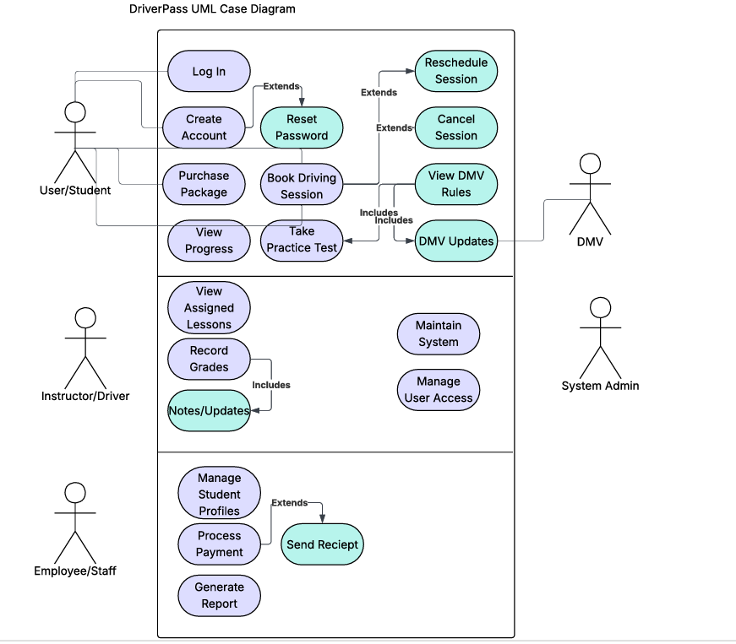

UML Activity Diagrams
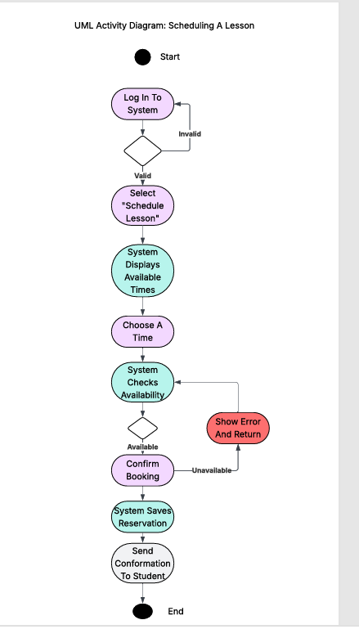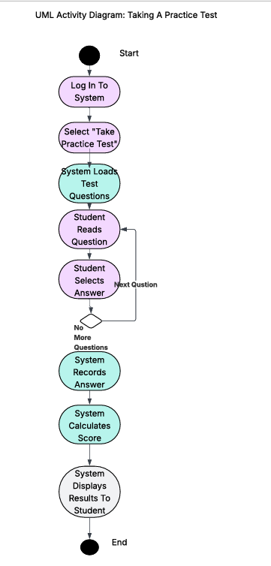

UML Sequence Diagram
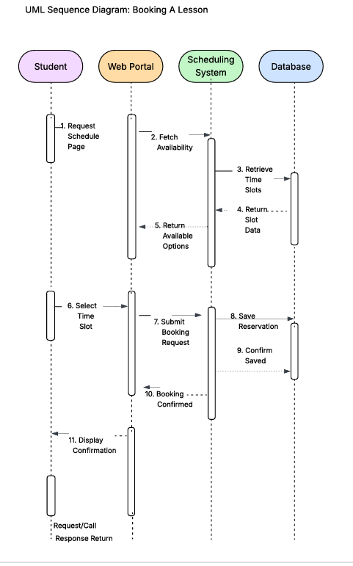

UML Class Diagram
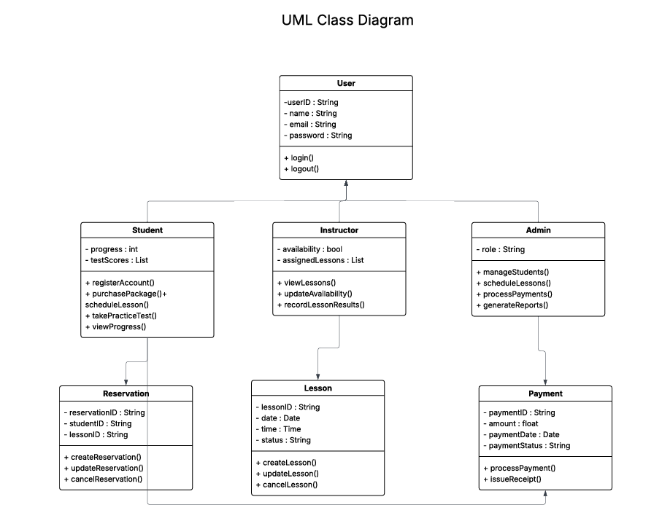

Technical Requirements
A cloud-based server is an ideal option for a small business that can experience greater growth in the future because it is affordable and has the flexibility to scale at any time. Also for all of the company employees that are involved with the daily operations of the company will need to have some type of computer that can efficiently run this system.

To keep customer information and administrative records from being lost, an automatic backup system should be used for the business's data protection. The system must also have security software installed to protect the company from malware and other threats to the company.

The administrative users must have a stable and reliable internet connection so that they can have access to the most current updates in regard to scheduling, reservations, and notices of any new policy changes from the DMV.

In addition, the DriverPass web portal must work with the most widely used operating systems, such as Mac OS, Windows, iOS, and Android so that the user group can easily reach the system.

